

Sec: INC.SR_*CO-SC(MODEL-B) Date: 31-07-22
Time: 3 Hrs Max. Marks: 300

31-07-22_ INC.SR.STAR CO-SUPER CHAINA(MODEL-B)_JEE-MAIN_CTM-53_SYLLABUS
PHYSICS: PRESENTWEEK (50%): EM Waves & Optical instruments: Electromagnetic waves and their characteristics, Transverse nature of electromagnetic waves, Electromagnetic spectrum (radio waves, microwaves, infrared, visible, ultraviolet. X-rays. Gamma rays), Applications of e.m. waves. Microscope and Astronomical Telescope (reflecting and refracting ) and their magnifying powers

PREVIOUS WEEK (25%): AC : Alternating currents, peak and RMS value of alternating current/ voltage: reactance and impedance: LCR circuit, resonance: Quality factor, power in AC circuits, wattless current. AC generator and transformer.

CUMULATIVE (25%): Syllabus covered From 03-05-21 TO 30-07-22
CHEMISTRY: PRESENTWEEK (50%): Biomolecules: Carbohydrates: Classification; preparation of glucose from sucrose and starch, Reactions of glucose with HI, NH2OH, Br2, Acylation, HNO3 Oxidation, Reduction; D, L- configuration, Glycoside formation cyclic structure of glucose, fructose, maltose, sucrose, lactose, Anomers, mutarotation, reducing and non- reducing sugars, poly saccarides- starch and cellulose, tests of carbohydrates (Exclude: Kiliani Fischer synthesis, Ruff degradation), Amino acids; iso electric point, Peptide linkage; Structure of peptides (primary and secondary); Types of proteins (fibrous and globular). Tests of amino acids
PREVIOUS WEEK (25%): Amines: Preparation from nitro compounds, nitriles and amides; Hoffmann bromamide degradation, Gabriel phthalimide synthesis, Physical properties, reaction with nitrous acid, alkylation, acylation, carbylamine reaction, hinsberg test, Hoffman mustard oil reaction, EAS of aniline, nitration, sulphonation, bromination, diazotisation, Azo coupling reaction of diazonium salts of aromatic amines; Sandmeyer and related reactions of diazonium salts;
CUMULATIVE (25%): Syllabus covered From 03-05-21 TO 30-07-22
MATHEMATICS: PRESENTWEEK (50%): STATISTICS: Measure of central tendency and dispersion, mean, median, mode, mean deviation, standard
deviation and variance of grouped and ungrouped data, analysis of the frequency distribution with same mean but different variance
PREVIOUS WEEK (25%): Cube roots of unity, De-Moivre's theorem,
nth roots of unity
CUMULATIVE (25%): Syllabus covered From 03-05-21 TO 30-07-22
PHYSICS MAX.MARKS: 100
Section – I
(SINGLE CORRECT ANSWER TYPE)
This section contains 20 multiple choice questions. Each question has 4 options (1), (2), (3) and (4) for its answer, out of which ONLY ONE option can be correct.
Marking scheme: +4 for correct answer, 0 if not attempted and -1 if not correct.
1. In an apparatus, the electric field was found to oscillate with an amplitude of 24V/m. The amplitude of the oscillating magnetic field will be
1) 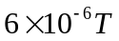 2) 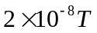 3) 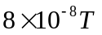 4) 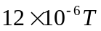
2. Which of the following statement is true?
1) The frequency microwaves is greater than that of UV-rays
2) The wavelength of IR rays is lesser than that of UV-rays
3) The wavelength of microwaves is lesser than that of IR rays
4) Gamma rays has least wavelength in the electromagnetic spectrum.
3. The energy associated with electric field is 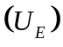 and with magnetic fields is 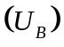for an electromagnetic wave in free space. Then
1) 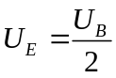 2) 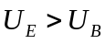 3) 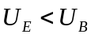 4) 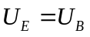
4. Choose the correct option relating wavelengths of different parts of electromagnetic wave spectrum.
1) 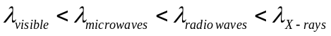 2) 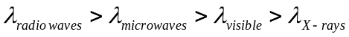
3) 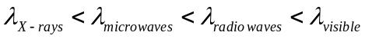 4) 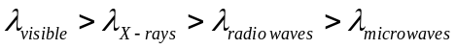
5. For a plane electromagnetic wave, the magnetic field at a point x and time t is
. The instantaneous electric field  corresponding to is (speed of light 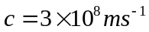)
1) 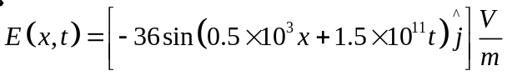
2) 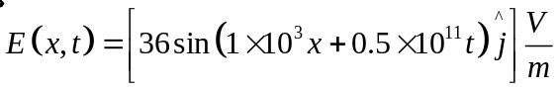
3) 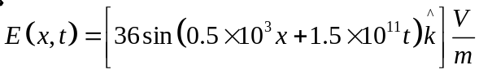
4) 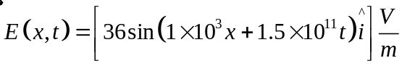
6. An electromagnetic wave in vaccum has the electric and magnetic field 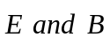, which are always perpendicular to each other. The direction of polarization is given by 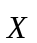and that of wave propagation by . Then
1) 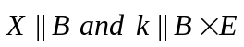 2) 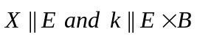 3) 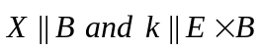 4) 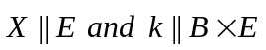
7. If we need a magnification of 375 from a compound microscope of tube length 150mm and an objective of focal length 5mm, the focal length of the eye-piece, should be close to
1) 22mm 2) 12mm 3) 2mm 4) 33mm
8. In a compound microscope, the focal length of objective lens is 1.2cm and focal length of eye piece is 3.0cm. When objective is kept at 1.25cm in front of objective, final image is formed at infinity. Magnifying power of the compound microscope should be
1) 200 2) 100 3) 400 4) 150
9. Your friend is having eye sight problem. She is not able to see clearly a distant uniform window mesh and it appears to her as non-uniform and distorted. The doctor diagnosed the problem as:
1) Astigmatism 2) Myopia with Astigmatism
3) Presbyopia with Astigmatism 4) Myopia and hypermetropia
10. The magnifying power of a telescope with tube 60cm is 5. What is the focal length of its eye piece?
1) 30cm 2) 40cm 3) 20cm 4) 10cm
11. The primary winding of a transformer has 500 turns where as its secondary has 5000 turns. The primary is connected to an A.C supply of 20V, 50Hz. The secondary will have an output of
1) 2V, 5Hz 2) 200V, 500Hz 3) 2V, 50Hz 4) 200V, 50Hz

12. In an LCR circuit shown the following figure, what will be the readings of the voltmeter across the resistor and ammeter if an a.c. source of 220V and 100Hz is connected to it as shown?
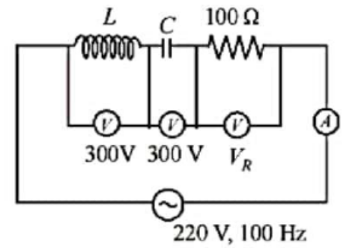
1) 800V, 8A 2) 110V, 1.1A 3) 300V, 3A 4) 220V, 2.2A
13. An AC circuit has 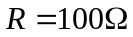,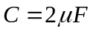 and L=80mH, connected in series. The quality factor of the circuit is
1) 2 2) 0.5 3) 20 4) 200
14. In LC circuit the inductance L=40mH and capacitance 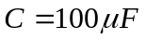. If a voltage 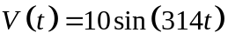 is applied to the circuit, the current in the circuit is given as
1) 0.52 cos 314t 2) 10 cos 314t 3) 5.2 cost 314t 4) 0.52 sin 314t
15. The power factor of an AC circuit having resistance (R) and inductance (L) connected in series and angular velocity is
1) 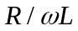 2) 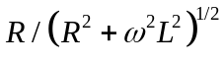 3) 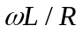 4) 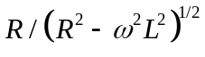
16. A carbon resistance has following colour code. What is the value of the resistance
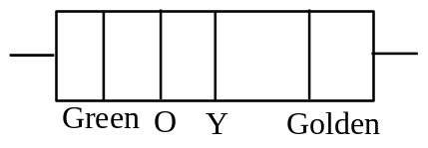
1) 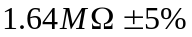 2) 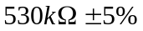 3) 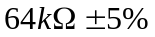 4) 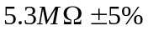
17. An electron, a proton and alpha particle having the same kinetic energy are moving in circular orbits of radii 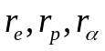 respectively in a uniform magnetic field B. The relation between is
1) 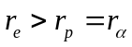 2) 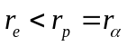 3) 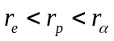 4) 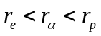
18. In a coil of resistance 100,a current is induced by changing the magnetic flux through it as shown in the figure. The magnitude of change in flux through the coil is
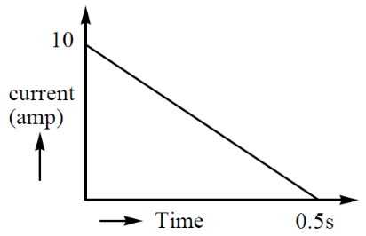
1) 250Wb 2) 275Wb 3) 200Wb 4) 225Wb
19. A square loop of side 20cm and resistance 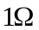is moved towards right a constant speed 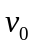. The right arm of the loop is in a uniform magnetic field of 5T. The field is perpendicular to the plane of the plane of loop and is going into it. The loop is connected to a network of resistor each of value 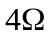. What should be the value of so that a steady current of 2mA flows in the loop?
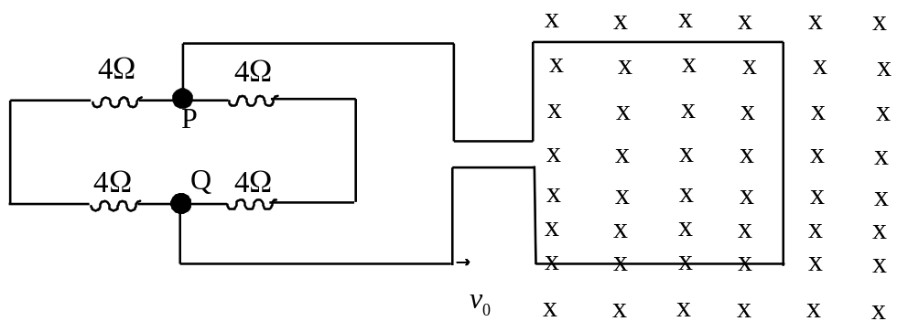
1) 1cm/s 2) 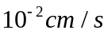 3) 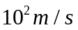 4) 1m/s

20. In the circuit shown in the figure, the total charge is 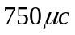 and the voltage across capacitor is 20V. Then the charge on capacitor is
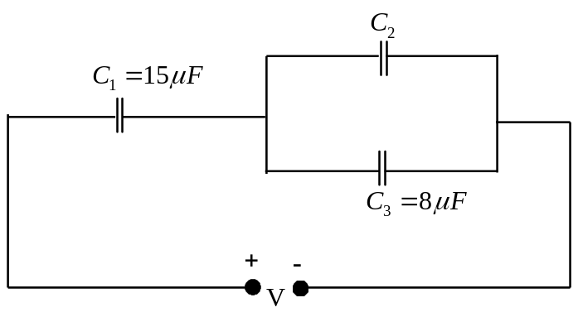
1) 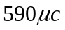 2) 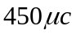 3) 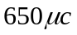 4) 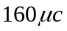
SECTION-II
(Numerical Value Answer Type)
This section contains 10 questions. The answer to each question is a Numerical value. If the Answer in the decimals , Mark nearest Integer only. Have to Answer any 5 only out of 10 questions and question will be evaluated according to the following marking scheme:
Marking scheme: +4 for correct answer, -1 in all other cases.
21. A plane electromagnetic wave of frequency 50MHz travels in free space along the positive x-direction. At a particular point in space and time, 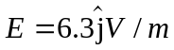. The corresponding field, at that point 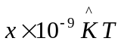. Find the value of x.
22. The magnetic field in a travelling electromagnetic wave has a peak value of 20nT. The peak value of electric field strength (in volt m⁻¹) is
23. The magnetic field of a plane electromagnetic wave is given by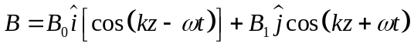. Where 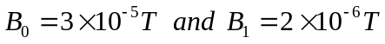. The rms value of the force (in newton) experienced by a stationary charge Q=10⁻⁴C at z=0 is 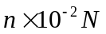. Find n value.
24. The focal lengths of the objective and the eyepiece of the reflecting telescope are 225cm and 5cm respectively. The magnifying power of the telescope will be
25. The magnifying power of a microscope with an objective of 5mm focal length is 40. The length of its tube is 20cm. Then the focal length (in mm) of the eye-piece is

26. An object viewed from a near point distance of 25cm, using a microscopic lens with magnification ‘6’, gives an unresolved image. A resolved image is observed at infinite distance with a total magnification double the earlier using an eyepiece along with the given lens and a tube of length 0.6m, if the focal length of the eyepiece is equal to ___cm.
27. A power transmission line feeds input power at 2300V to a step down transformer with its primary windings having 4000 turns. The output power is delivered at 230V by the transformer. If the current in the primary of the transformer is 5A and its efficiency is 90%, the output current (in ampere) would be
28. An alternating voltage 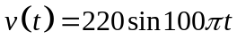volt is applied to a purely resistive load of 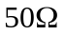. The time taken for the current to rise from half of the peak value to the peak value is 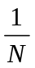sec then the value of N is
29. A 60Hz AC voltage of 160V impressed across an LR-circuit results in a current of 2A, if the power dissipation is 200W, calculate the maximum value of the back emf (in volt) arising in the inductance.
30. Given LCR circuit has L=5H, 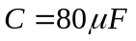, 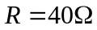and variable frequency source of 200V. The source frequency (in Hz) which drives the circuit at resonance is 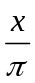. Find the value of x.
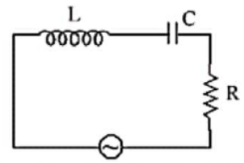

CHEMISTRY MAX.MARKS: 100
Section – I
(SINGLE CORRECT ANSWER TYPE)
This section contains 20 multiple choice questions. Each question has 4 options (1), (2), (3) and (4) for its answer, out of which ONLY ONE option can be correct.
Marking scheme: +4 for correct answer, 0 if not attempted and -1 if not correct.
31. Aniline dissolved in dilute HCl is reacted with sodium nitrate at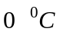. This solution was added dropwise to a solution containing equimolar mixture of aniline and phenol in dil HCl. The structure of the major product is
1)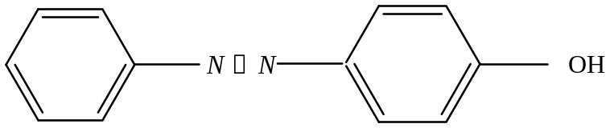
2)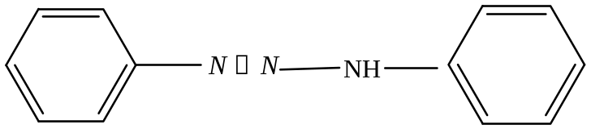
3)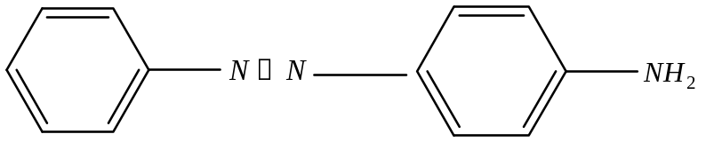
4)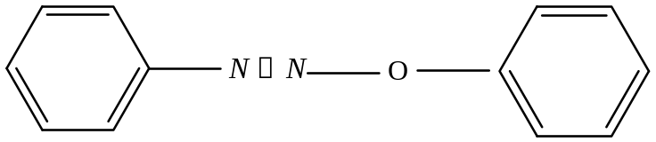
32. The major formed in the following reaction is
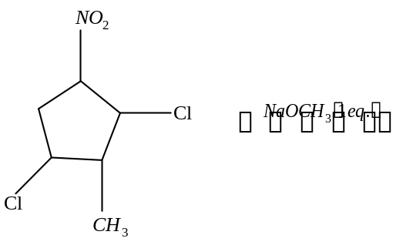
1)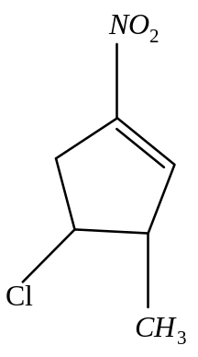 2)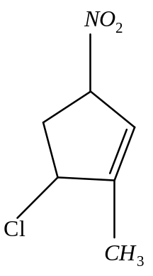 3)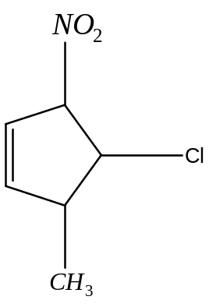4)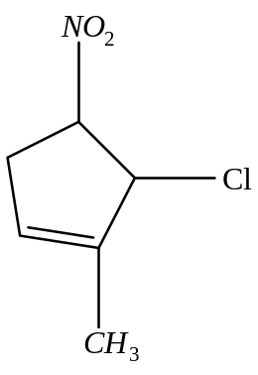

33. The increasing order of nitration of the following compounds is:
I) 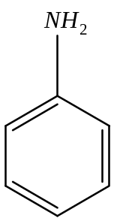 II) 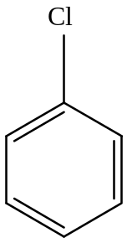 III) 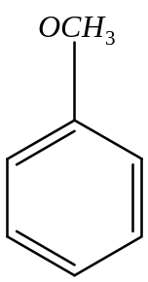 IV) 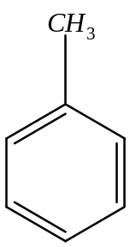
(1)(I)< (II)<(IV)< (III) (2)(I)< (II)<(III)< (IV)
(3)(II)< (I)<(III)< (IV) (4)(II)< (I)<(IV)< (III)
34. Which of the following compounds will form significant amount of meta products during mono-nitration reaction?
1)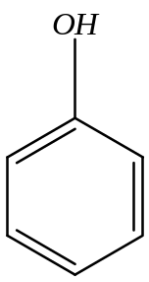 2)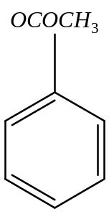 3)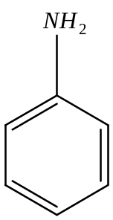 4)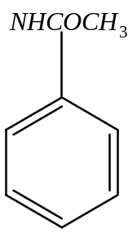
35. The conversion of benzene diazonium chloride to bromobenzene can be accomplished by
(1)Reimer-Tiemann reaction (2)Friedel-Crafts reaction
(3)Gattermann reaction (4)Azo-Coupling reaction
36. What will be the major product in the following mononitration reaction?
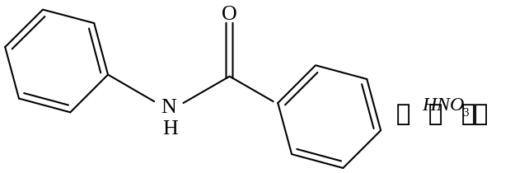
1)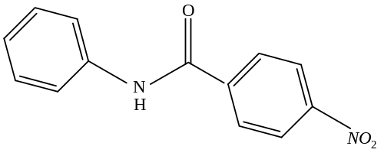 2)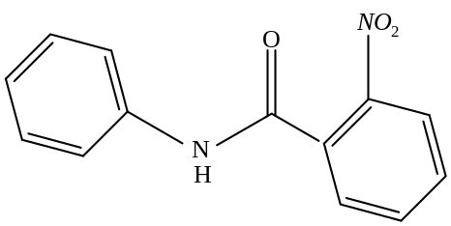
3)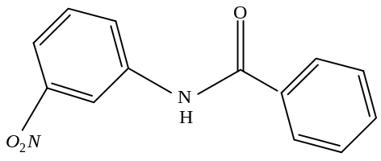 4)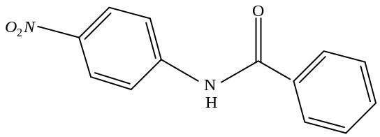
37. The compounds A and B in the following reaction are, respectively:
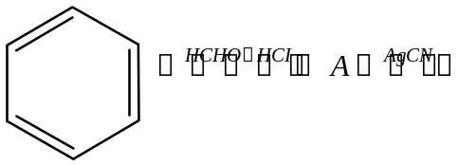
1)A= Benzyl alcohol, B= Benzyl cyanide
2)A=Benzyl chloride, B=Benzyl cyanide
3) A=Benzyl alcohol, B=Benzyl isocyanide
4)) A=Benzyl chloride, B=Benzyl isocyanide
38. The major product of the following reaction is:
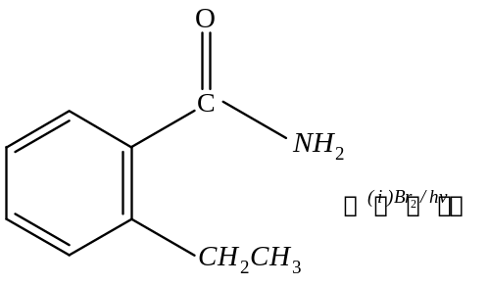
1)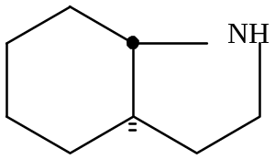 2)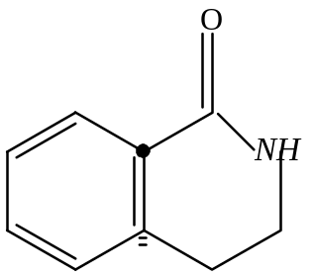
3)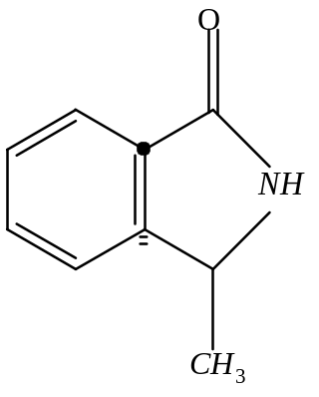 4)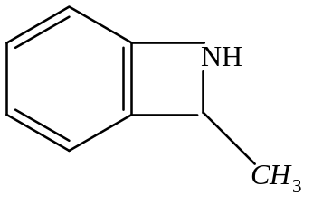
39. Which one of the following statements is not true?
1) Lactose contain glycosidic linkage between 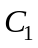of galactose and 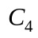 of glucose.
2) Lactose is a reducing sugar and it gives Fehling’s test.
3) Lactose 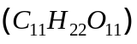is a disaccharide and it contains 8 hydroxyl groups.
4) On acid hydrolysis, lactose gives one molecule of D(+)-glucose and one molecule of D(+)-galactose
40. Consider the following reactions:
(i) Glucose + ROH 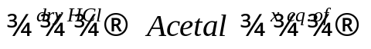 acetyl derivative
(ii) Glucose 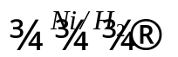A 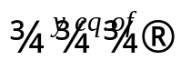 acetyl derivative
(iii) Glucose 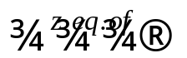 acetyl derivative
‘X’,’y’ and ‘z’ in these reaction are respectively.
1) 5,4 & 5 2) 4,6 & 5 3) 4,5 & 5 4) 5,6 & 5
41. Which of the following statement is not true for glucose?
1) Glucose exist as in two crystalline forms 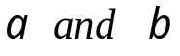
2) Glucose gives Schiff’s test for aldehyde
3) Glucose reacts with hydroxylamine to form oxime .
4) The pentaacetate of glucose dose not react with hydroxylamine to give oxime
42. Which of the following statements is correct?
1) Gluconic acid can form cyclic (acetal/hemiacetal) structure
2) Gluconic acid is a dicarboxylic acid
3) Gluconic acid is a partial oxidation product of glucose
4) Gluconic acid is a obtained by oxidation of glucose with 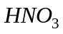
43. Which of the following compounds will behave as a reducing sugar in an aqueous KOH solution?
1)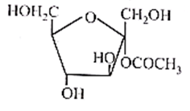 2)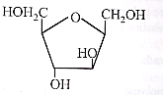
3)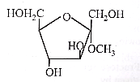 4)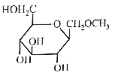

44. The incorrect statement among the following:
1) -D-glucose and -D-glucose are anomers.
2) -D-glucose and -D-glucose are enantiomers.
3) Cellucose is a straight chain polysaccharide made up of only -D-glucose units.
4) The penta acetate of glucose does not react with hydroxyl amine.
45. Which of the following is NOT an example of fibrous protein?
1) Keratin 2) Albumin 3) Collagen 4) Mysosin
46. The correct structure of histidine in a strongly acidic solution 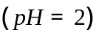 is:
1)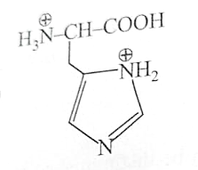 2)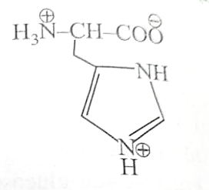
3)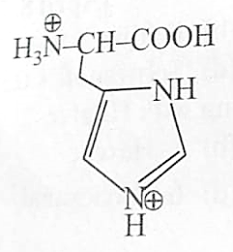 4)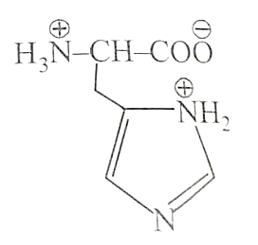
47. The correct sequence of amino acids present in the tripeptide given below is:
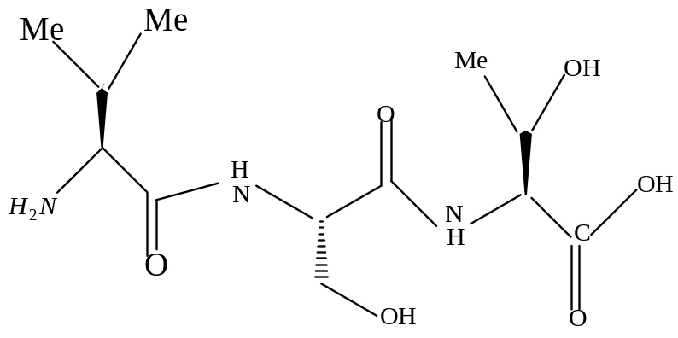
1) Val – Ser – Thr 2) Thr – Ser – Val 3) Leu – Ser – Val 4) Thr – Ser – Leu
48. Which of the following will not exist in zwitter ionic form at pH=7?
1) 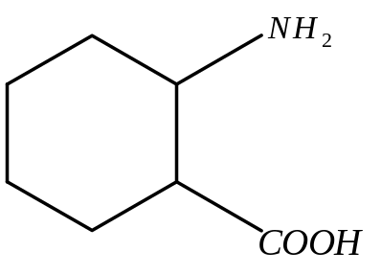 2)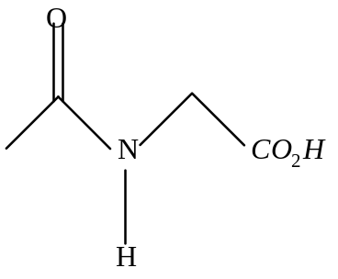
3)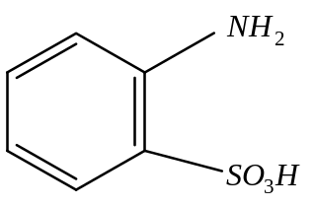 4)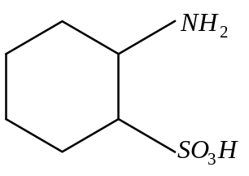
49. The correct structure of product ‘P’ in the following reaction is:
Asn – ser + 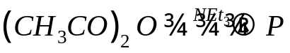
(excess)
1)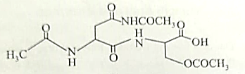
2)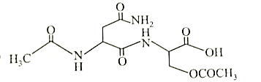
3)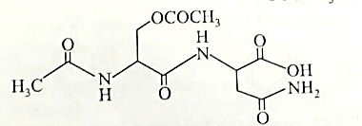
4)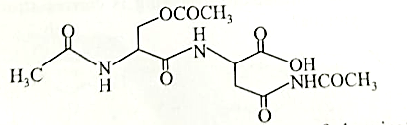

50. The major product (P) of the given reaction is (where, Me is –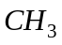)
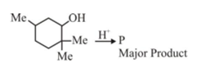
1)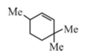 2)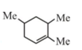 3)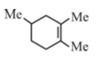 4)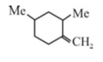

SECTION-II
(Numerical Value Answer Type)
This section contains 10 questions. The answer to each question is a Numerical value. If the Answer in the decimals , Mark nearest Integer only. Have to Answer any 5 only out of 10 questions and question will be evaluated according to the following marking scheme:
Marking scheme: +4 for correct answer, -1 in all other cases.
51. In the given reaction
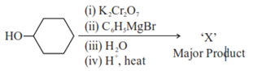
the number of 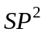 hybridised carbon (s) in compound 'X' is_____.
52. . In the given reaction
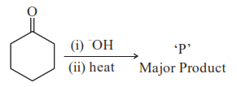
The number of electrons present in the product 'P' is _____.
53.
The number of carbon atoms present in the product B is_____.
54. Observe structures of the following compounds
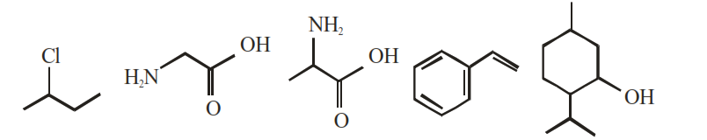
The total number of structures/compounds which possess asymmetric carbon atoms is

55. Given below are two statements :
Statement I : The esterification of carboxylic acid with an alcohol is a nucleophilic acyl substitution.
Statement II : Electron withdrawing groups in the carboxylic acid will increase the rate of esterification reaction. Choose the most appropriate option :
(1) Both Statement I and Statement II are correct.
(2) Both Statement I and Statement II are incorrect.
(3) Statement I is correct but Statement II is incorrect
(4) Statement I is incorrect but Statement II is correct.
56. The number of chiral alcohol(s) with molecular formula 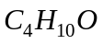 is______.
57. The correct structure of product ‘A’ formed in the following reaction.
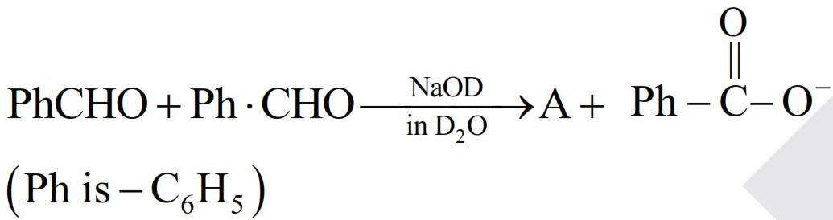
1) 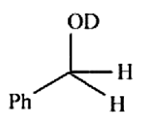 2) 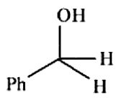 3) 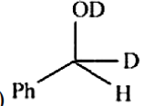 4) 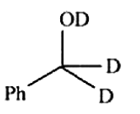
58. Compound 'P' on nitration with dil. yields two isomers (A) and (B). These isomers can be Separated by steam distillation. Isomers (A) and (B) show the intramolecular and intermolecular hydrogen bonding respectively. Compound (P) on reaction with conc. yields a yellow compound 'C', a strong acid. The number of oxygen atoms is present in compound 'C' ________.
59. How many of the given compounds will give a positive Biuret test ______?
Glycine, Glycylalanine,Tripeptide, Biuret
60. A protein ‘A’ contains 0.30% of glycine (molecular weight 75). The minimum molar mass of the protein ‘A’ is _____ 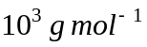

MATHEMATICS MAX.MARKS: 100
Section – I
(SINGLE CORRECT ANSWER TYPE)
This section contains 20 multiple choice questions. Each question has 4 options (1), (2), (3) and (4) for its answer, out of which ONLY ONE option can be correct.
Marking scheme: +4 for correct answer, 0 if not attempted and -1 if not correct.
61. If 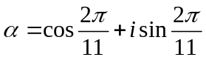 then 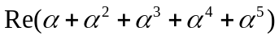equals
1) 0 2) -1/2 3) 1/2 4) 2
62. All the complex numbers z that satisfy the equation 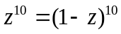lie on
1) 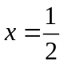 2) 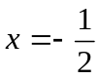 3) 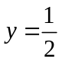 4) 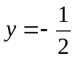
63. Let z = cos θ+isinθ. Then the value of 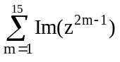 at θ = 2º is
1) 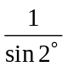 2) 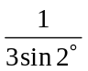 3) 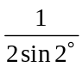 4) 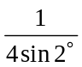
64. 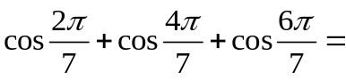
1) 1 2) 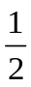 3) 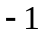 4) 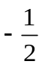
65. 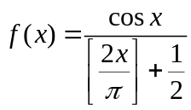 (where x is not integral multiple of and [.] denotes the greatest integer function) is
1) an odd function 2) an even function 3) neither odd nor even 4) none of these
66. 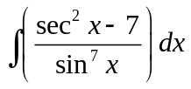 =
1) 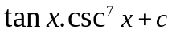 2) 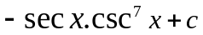 3) 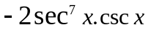 4) 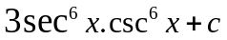
67. If 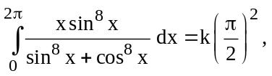 then the value of k is
1) 5 2) 4 3) 6 4) 2

68. The area of region bounded by 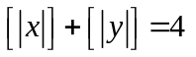is ‘4u’ (Here [.] denotes G.I.F). Then u =
1) 5 2) 4 3) 6 4) 2
69. The locus of the centre of the circle which touches the y-axis and also touches the circle 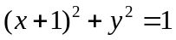 externally is
1) 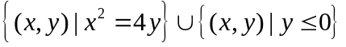 2) 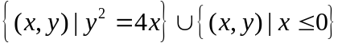
3) 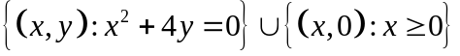 4) 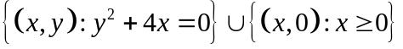
70. If f(x) is decreasing function then the set of value of ‘k’ , for which the major axis of the ellipse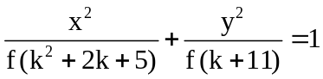 is the x-axis , is
1) k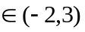 2) k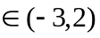
3)k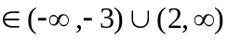 4)k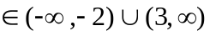
71. The mean deviation from the mean of the series 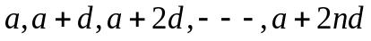
1) 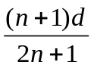 2) 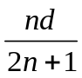 3) 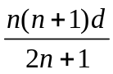 4) 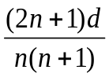
72. The arithmetic mean of the square of the first n natural number is
1) 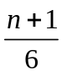 2) 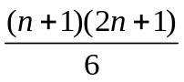 3) 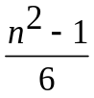 4) None of them
73. The mean height of 25 male workers in a factory is 161 cms, and the mean height of 35 female workers in the same factory is 158 cms. The combined mean height of 60 workers in the factory is
1) 159.25 2) 158.25 3) 159.75 4) 158.75
74. If the standard deviation of a variable X is, then the standard deviation of variable 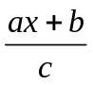is
1) 2) 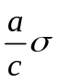 3) 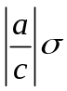 4) 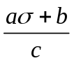
75. For two data sets, each of size 5, the variants are given to be 4 and 5 and the corresponding means are given to be 2 and 4 respectively the variance of combined data set is
1) 6 2) 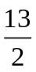 3) 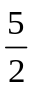 4) 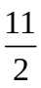
76. In any discrete series (when all the values are not same) the relationship between mean deviation(M.D ) about Mean and standard deviation (S.D) is
1) M.D=S.D 2) M.D > S.D 3) M.D < S.D 4) M.D S.D
77. The geometric mean of 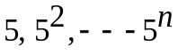 is
1) 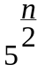 2) 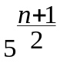 3) 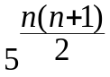 4) None of these
78. Consider the numbers 1, 2, 3,4,5, 6, 7, 8,9,10. If 1 is added to each number, the variance of the numbers so obtained is
1) 6.5 2) 2.87 3) 3.87 4) 8.25
79. The mean of the numbers a, b, 8,5,10 is 6 and the variance is 6.80 then possible values of a and b?
1) a=0, b=7 2) a=5, b=2 3) a=1, b=6 4) a=3, b=4
80. If A = 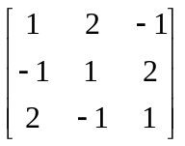, then det (adj (adj A)) is
1) 14⁴ 2) 14³ 3) 14² 4) 14

SECTION-II
(Numerical Value Answer Type)
This section contains 10 questions. The answer to each question is a Numerical value. If the Answer in the decimals , Mark nearest Integer only. Have to Answer any 5 only out of 10 questions and question will be evaluated according to the following marking scheme:
Marking scheme: +4 for correct answer, -1 in all other cases.
81. The variance of first 20 natural numbers is
82. The value of median for the data
Income in Rs | 1000 | 1100 | 1200 | 1300 | 1400 | 1500
No of persons | 14 | 26 | 21 | 18 | 28 | 15

83. If 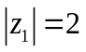, 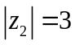, 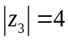 and 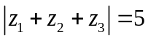 then 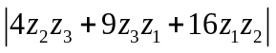 =
84. If 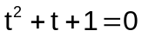, then the value of 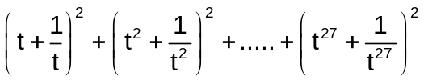 is
85. If w is imaginary 5th root of unity then 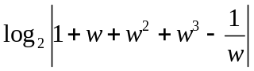 =
86. For all complex numbers 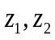 satisfying 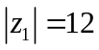 and 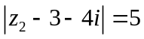, the minimum value of 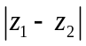 is
87. The arithmetic mean of the roots of the equation 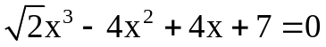is 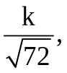then the value of k is___
88. If the mean of a set of observations 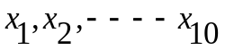 is 20 then the mean of 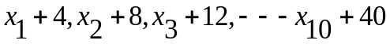 is
89. A man travels at a speed of 20 km/hr and then returns at a speed of 30 km/hr his average speed of whole journey in km/hr is
90. If the mean deviation about the median of the numbers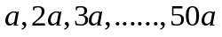 is 50 then 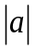 equals.

